**Heaven’s Light is Our Guide**



**Rajshahi University of Engineering and Technology**

**Department of Computer Science and Engineering**

**Course No:** CSE.1204

**Course Title:** Sessional based on CSE.1203 (Object Oriented Programming)

**Lab Report No:** 01

**Lab Report On:** Class in C++

**Submitted By** **Submitted To**

Md. Ariful Islam Md. Asifur Rahman

Roll No: 1803046 Lecturer

Section: A Dept. of CSE,RUET

Department: CSE

**Problem No:** 01

**Problem Statement:** Implementation of the Following Class

Number

|  |
| --- |
| int x;  int y;  float result; |
| Number ( );  Number (int,int);  void Add ( );  void Sub ( );  void Mul ( );  void Div ( );  float get_result ( ); |

**Theory :**

**#Class** is a user-defined type or data structure declared with keyword class that has data and functions as its members whose access is governed by the three access specifiers private, protected or public. By default access to members of a C++ class is private. We can access or use private data with the help of **accessor** and **mutator**.

An **Accessor** function and the **Mutator** function are like the set and get functions. They are used instead of making a **class** member variable public and changing it directly within an object. To access a private object member, an **accessor** function must be called and to manipulate a private object member, a **mutator** function must be called.

Another special feature is **Constructor**. Constructor is a function that is called at the time of object creation. There are three properties of a Constructor :

1. **Name of the constructor is same as the class name.**
2. **Constructor has to be public.**
3. **It has no return type.**

In C++ different functions can have the same name with different parameters and it is called **Polymorphism**. When we call these functions, these will be called according to their parameters. It is called **Function Overloading**.

While working on a project, a C++ program should have at least 3 files :

1. **Main.cpp** : It is the file where we write the command or steps a program.
2. **Class Name.h** : It is the file where we write the class **variables** and **Function prototypes** with Access Modifiers .
3. **Class Name.cpp** : In this file we write down the **details** of functions that we have written in **Class name.h** file.

**Source Code :**

1. main.h

|  |
| --- |
| #include <iostream>  #include "Number.h"  using namespace std;  int main()  {  Number N(20,40);  N.Add();  cout<<N.get_result()<<endl;  N.Sub();  cout<<N.get_result()<<endl;  N.Mul();  cout<<N.get_result()<<endl;  N.Div();  cout<<N.get_result()<<endl;  return 0;  } |

1. Number.h

|  |
| --- |
| #ifndef NUMBER_H  #define NUMBER_H  class Number  {  int x;  int y;  float result;  public:  Number();  Number(int,int);  void Add();  void Sub();  void Mul();  void Div();  float get_result();  };  #endif |

1. Number.cpp

|  |
| --- |
| #include "Number.h"  Number::Number( ){ x=0 ; y=0 ; }  Number::Number(int a,int b){ x = a ; y = b ;}  void Number::Add( ){ result = x+y ; }  void Number::Sub( ){ result = x – y ; }  void Number::Mul( ){ result = x * y ; }  void Number::Div( ){ result = (float) x / y ; }  float Number::get_result( ){ return result ; } |

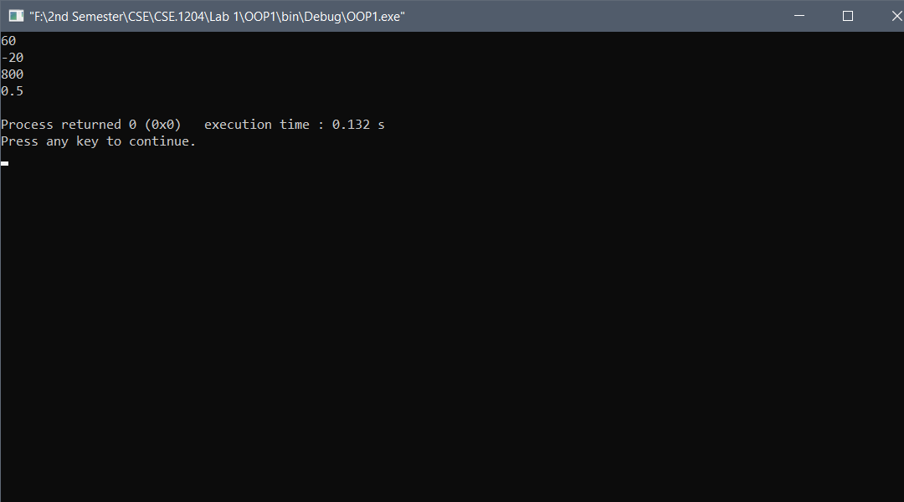**Output :**

**Conclusion :** After trying twice, I completed the program. But still I was facing some problem to handle **float** type data. Then with the help of our Course teacher I learnt to work with float type data.

**The End**